BRICK – PANELS  DEPOSITED PANEL | 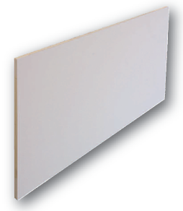
PHENOL - RIGID FOAM PANELS  High Performance Insulation extra for Brick-Panels and Joint Alignment System  Characteristics data  Compound system and Joint alignment system  Phenol-rigid foam (deposited panel) WLS 022, WLS 024 |  | Stand 06.2011  Date: 30.06.2011
Phenol-rigid foam | CFC-and HCFC-free, guaranteed quality
Properties: | Non-glowing, non-melting, and is not dropping off whilst burning,  Biological harmless, non-rotting, recyclable, mould and mildew-resistant.
Apparent density | >35 kg/m² in accordance with DIN EN 1602
Rated value of thermal  conductivity | λ 0,022 W/(m-K) in accordance with DIN EN 4108-4, 45-120 mm  λ 0,024 W/(m-K) in accordance with DIN EN 4108-4, 25-44 mm
OK | 38 in accordance with DIN EN 12086
Application type | WAB in accordance with DIN EN 4108-10
Construction material class  Deposited rigid foam  With brick tiles | B1 in accordance with DIN EN 4102 System can be used up to 22 meter  Other high on request
Temperature resistance | -30˚C to +110˚C -22˚F to +230˚F
Coating | Double sided coating made of special geomembrane
Edge finishing | Around, straight
Dimension/Format | On request
General | More characteristics data on request
 | Fourways ML  42 Valentines Road  Ilford, ESSEX  London IG1 4SA | Tel./fax: +44(0)20822271036  +44(0)7712284159  +44(0)7545966558  e.mail: info@brick-panels.co.uk  www.brick-panels.co.uk

The above information is based on current knowledge and experience. No binding assurance in respect of certain properties or suitability for certain applications must be read into our information. Patent rights and other proprietary rights must be observed if necessary.

Please note: As part of our continuing product development and improvement policy, we reserve the right to change product specifications without prior notice. Product colour may vary on screen so please visit the contact us page to order a copy of our product guide for more accurate colour specifications.

26.03.2013

